Netflix Movies & TV Shows Analysis Dashboard

Project Documentation

1. Project Title
Netflix Movies & TV Shows Analysis Dashboard

2. Project Overview
The Netflix Movies & TV Shows Analysis Dashboard is an end-to-end Data Analytics project developed to explore and analyze Netflix content data.
The purpose of this project is to understand Netflix's content distribution, identify trends, and extract meaningful insights using data analysis and visualization techniques.
The project follows a complete data analytics workflow:
- Data Collection
- Data Cleaning
- Data Preprocessing
- Exploratory Data Analysis (EDA)
- Data Visualization
- Interactive Dashboard Development
The final dashboard was developed using Streamlit, allowing users to interact with analyzed Netflix data through visual charts and summary statistics.

3. Project Objectives
The main objectives of this project are:
- Analyze Netflix movies and TV shows dataset.
- Understand content distribution patterns.
- Identify popular genres and countries.
- Analyze ratings and audience categories.
- Study content growth trends over years.
- Explore movie duration patterns.
- Build an interactive analytics dashboard.

4. Dataset Description

Dataset Source
The dataset used in this project is:
Netflix Movies and TV Shows Dataset
Source:
Kaggle Dataset
File Name:
netflix_titles.csv

Dataset Information
Number of Records:
8807 rows
Number of Attributes:
12 columns

5. Dataset Features
Column Name | Description
show_id | Unique identifier for each Netflix title
type | Content type (Movie or TV Show)
title | Name of movie or TV show
director | Director information
cast | Actors involved in the title
country | Production country
date_added | Date when content was added to Netflix
release_year | Original release year
rating | Audience rating classification
duration | Movie duration or number of seasons
listed_in | Genres/categories
description | Summary of content

6. Technologies Used

Programming Language

Python
Python was used as the main programming language for:
- Data processing
- Data analysis
- Visualization
- Dashboard development

Libraries Used

Pandas
Purpose:
- Reading dataset
- Data manipulation
- Data cleaning
- Data aggregation
Example:
pd.read_csv()

NumPy
Purpose:
- Numerical operations
- Handling calculations
- Data processing support

Matplotlib
Purpose:
Used for creating visualizations such as:
- Bar charts
- Line charts
- Histograms

Seaborn
Purpose:
Used for:
- Statistical visualization
- Improved chart presentation
- Data distribution analysis

Streamlit
Purpose:
Used to convert Python analysis into an interactive web dashboard.
Command used:
streamlit run app.py

7. Project Workflow
The complete workflow of this project is:
Raw Dataset

↓

Data Understanding

↓

Data Cleaning

↓

Feature Engineering

↓

Exploratory Data Analysis

↓

Data Visualization

↓

Streamlit Dashboard

8. Data Cleaning Process
The raw Netflix dataset contained missing values and inconsistent formats.
The following cleaning operations were performed:

Handling Missing Values
Missing values were identified using:
df.info()
Important missing fields were handled to improve analysis quality.
Examples:
- Missing director values
- Missing country information
- Missing ratings

Removing Duplicate Records
Duplicate entries were removed using:
df.drop_duplicates()
Purpose:
To avoid repeated information affecting analysis results.

Data Type Conversion
Date columns were converted into proper datetime format.
Example:
date_added
was converted to extract useful information such as:
year_added

9. Feature Engineering
Feature engineering was performed to create useful attributes from existing data.

Year Added Feature
Original column:
date_added
New feature:
year_added
Purpose:
Used for analyzing Netflix content growth over time.

Duration Value Feature
Original:
duration = 120 min
Converted into:
duration_value = 120
Purpose:
Allowed numerical analysis of movie duration.

10. Exploratory Data Analysis (EDA)
Exploratory Data Analysis was performed to discover patterns and insights from Netflix content.

Analysis 1: Movies vs TV Shows Distribution
Question:
What type of content is more common on Netflix?
Visualization:
Bar Chart
Insight:
Netflix contains a larger number of movies compared to TV shows.

Analysis 2: Netflix Content Growth Over Years
Question:
How has Netflix expanded its content library?
Visualization:
Line Chart
Insight:
Netflix content increased significantly over recent years.

Analysis 3: Top Producing Countries
Question:
Which countries contribute the most Netflix content?
Technique:
Multiple countries were separated using:
- split()
- explode()
Visualization:
Horizontal Bar Chart
Insight:
The United States and other major content-producing countries contribute significantly to Netflix.

Analysis 4: Popular Genres
Question:
Which genres are most common on Netflix?
Technique:
Genre values were separated and analyzed.
Visualization:
Bar Chart
Insight:
Drama, Comedy, and International content are among the most frequent categories.

Analysis 5: Ratings Distribution
Question:
What audience categories dominate Netflix?
Visualization:
Bar Chart
Insight:
TV-MA and TV-14 are among the most common ratings.

Analysis 6: Movie Duration Analysis
Question:
What is the common duration of Netflix movies?
Visualization:
Histogram
Insight:
Most movies have durations around 90–120 minutes.

Analysis 7: Director and Actor Analysis
The dataset contained multiple directors and actors in single rows.
Solution:
Used:
split()
explode()
Purpose:
To analyze individual directors and actors separately.

11. Dashboard Features
The Streamlit dashboard provides:

KPI Cards
Displays:
- Total Titles
- Number of Movies
- Number of TV Shows
- Countries

Interactive Filters
Users can filter data based on:
- Content Type
- Year
- Other available categories

Visualizations
The dashboard includes:
- Bar Charts
- Line Charts
- Histograms
- Distribution Charts

12. Project Structure
Netflix-Movies-TV-Shows-Analysis

│
├── app.py
│
├── datacleaning.py
│
├── visualizations.py
│
├── requirements.txt
│
└── data
└── netflix_titles.csv

14. Key Learning Outcomes
Through this project, I learned:
- Working with real-world datasets.
- Data cleaning techniques using Pandas.
- Handling missing and inconsistent data.
- Feature engineering concepts.
- Exploratory Data Analysis methods.
- Creating meaningful visualizations.
- Building interactive dashboards using Streamlit.
- Presenting analytical insights.

15. Conclusion
The Netflix Movies & TV Shows Analysis Dashboard demonstrates the complete workflow of a Data Analytics project.
By cleaning, analyzing, and visualizing Netflix data, this project provides insights into content trends, genres, countries, ratings, and audience preferences.
This project improved practical skills in Python, data analysis, visualization, and dashboard development while following a real-world analytics approach.

Dasboard Overview

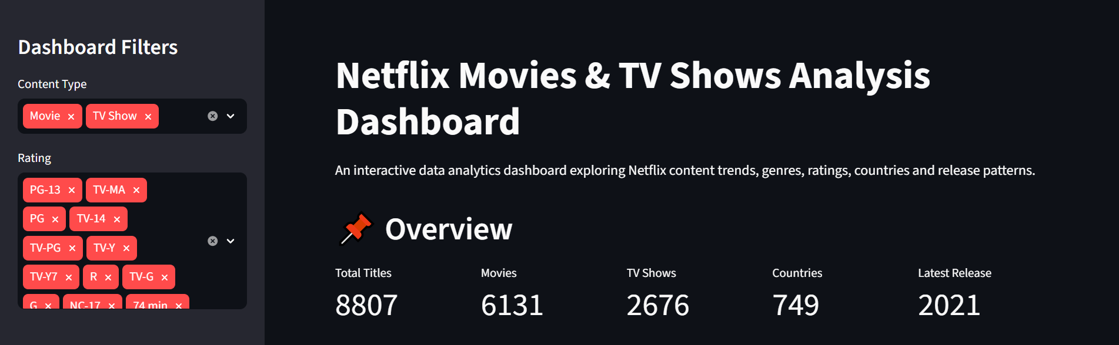
Content Overview

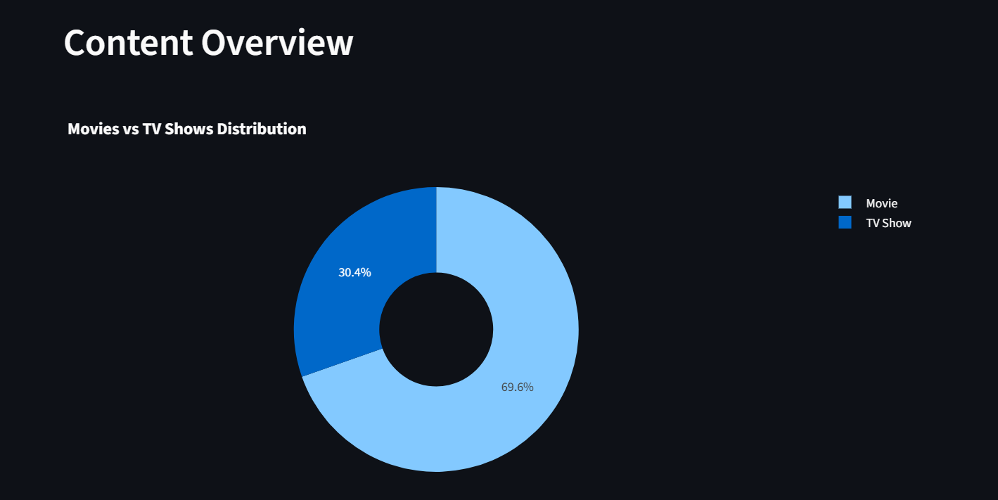

Content Growth Trend

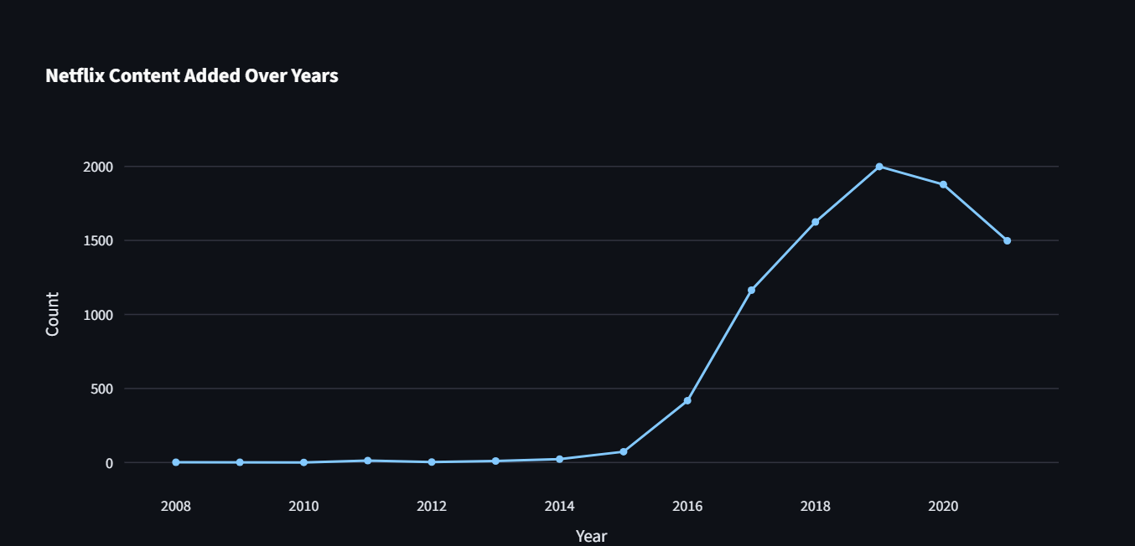

Top Countries

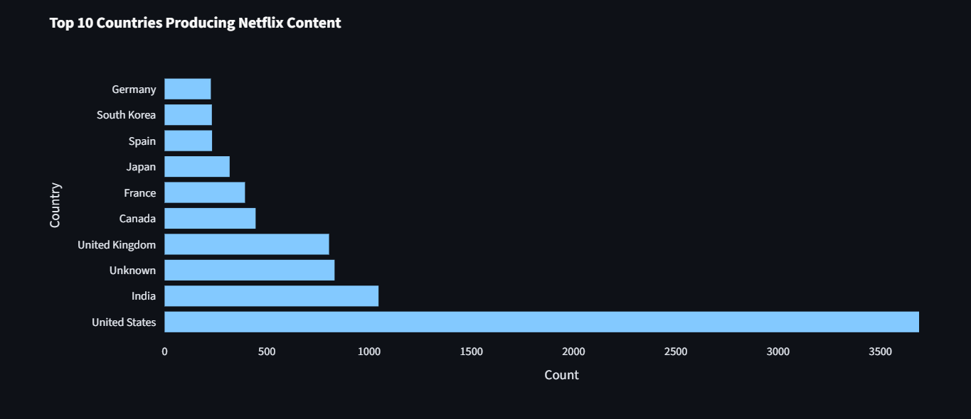

Country And Genre Relationship

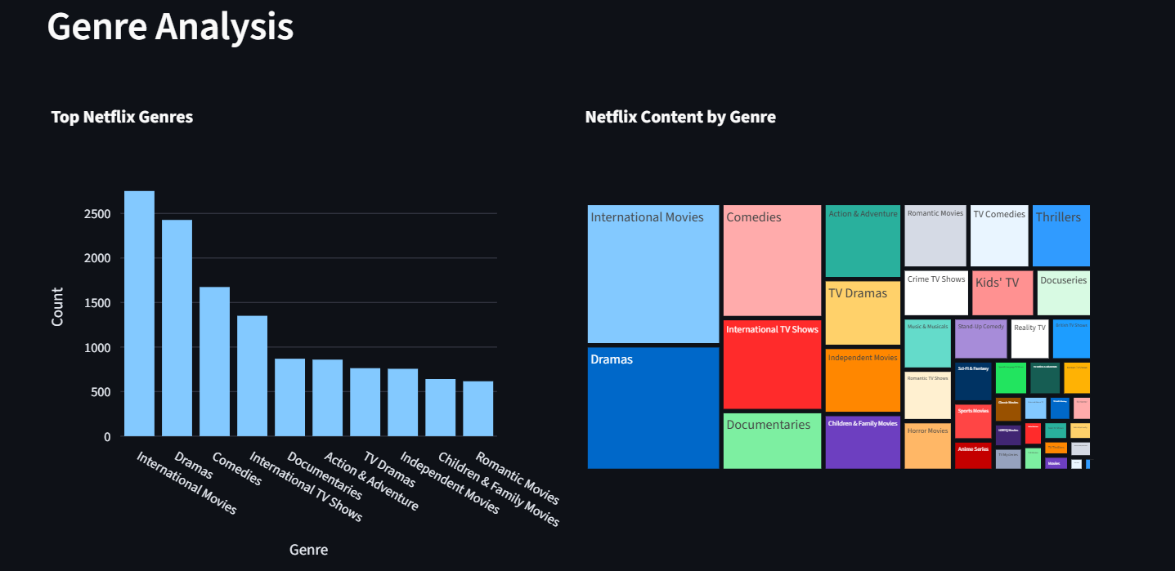

Rating Analysis

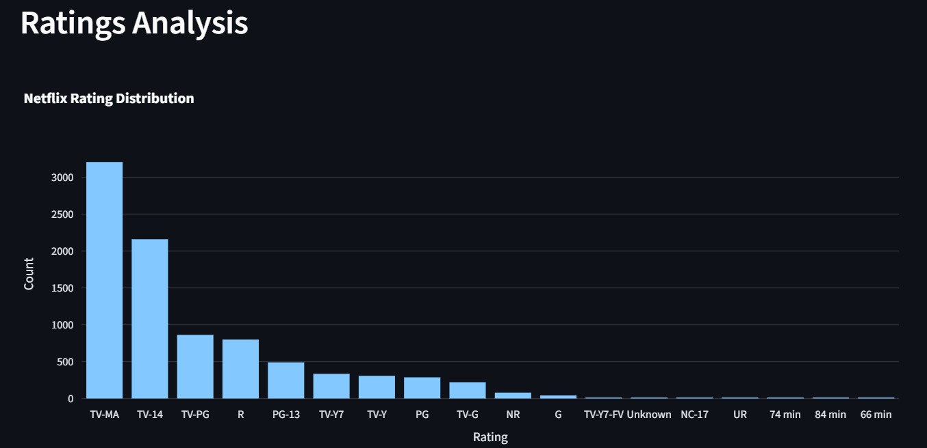

Time Based Analysis
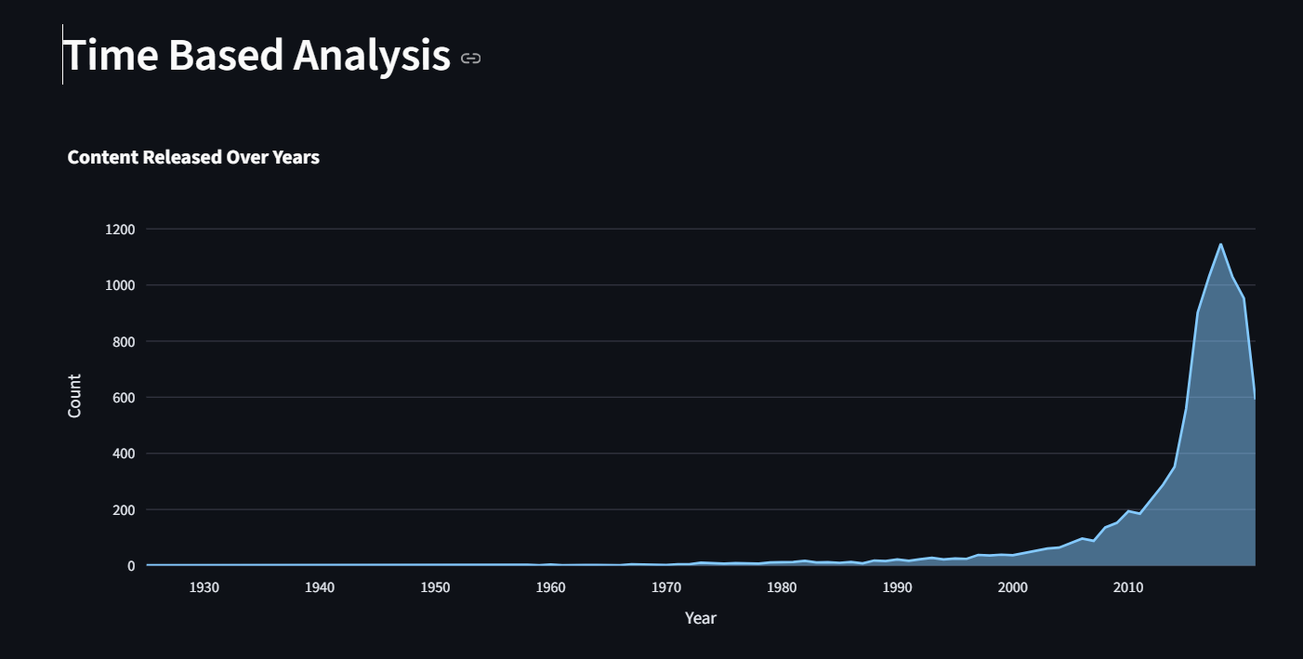

Content By Month

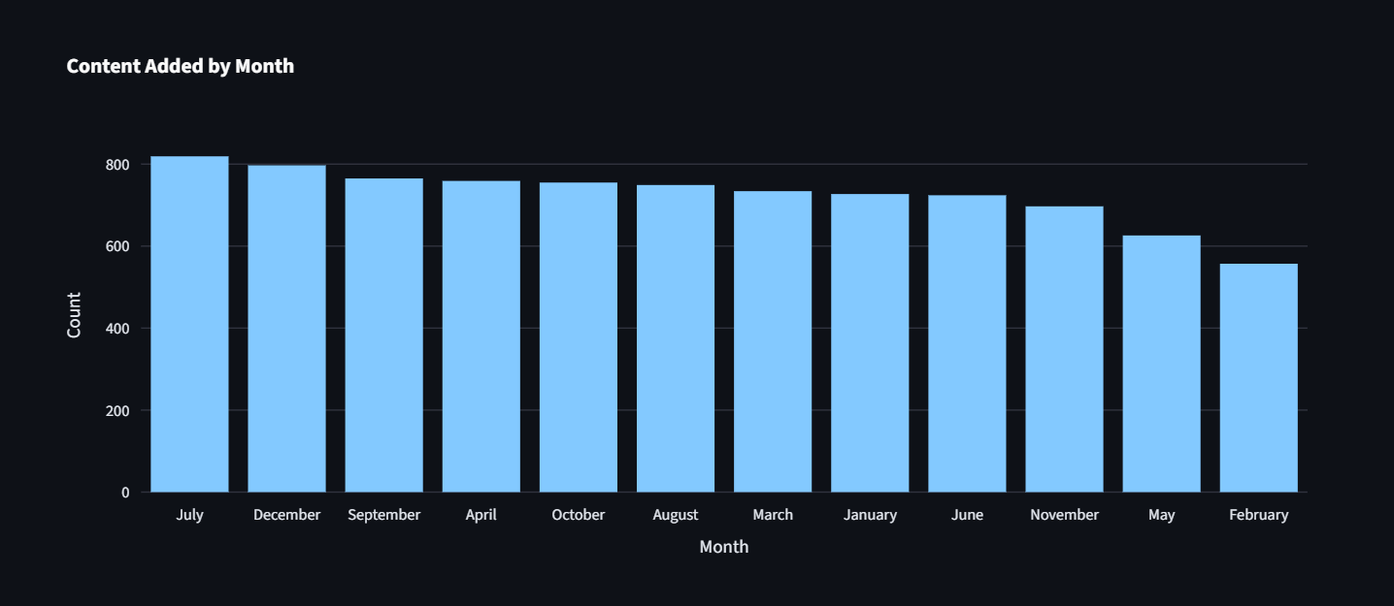

HeatMap

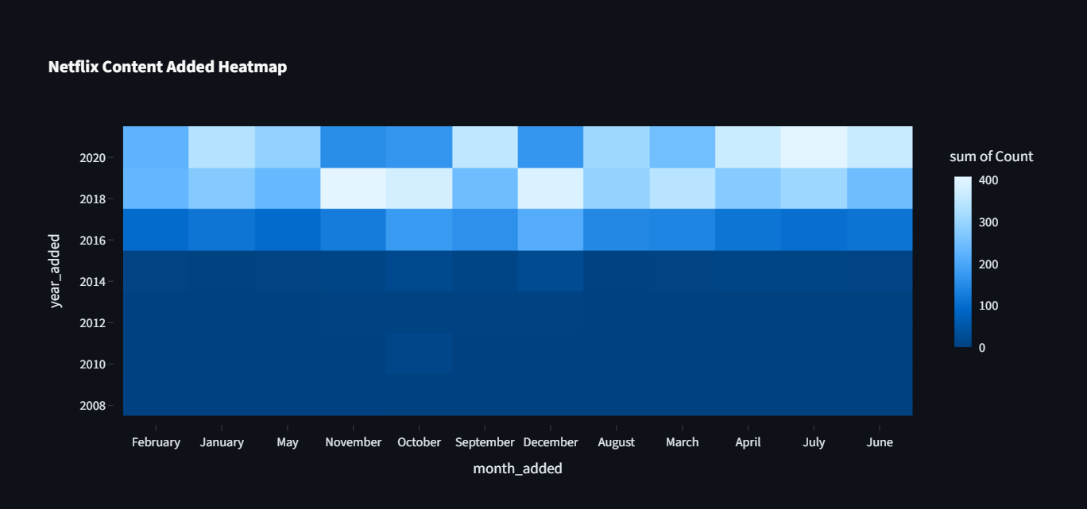

Content Details
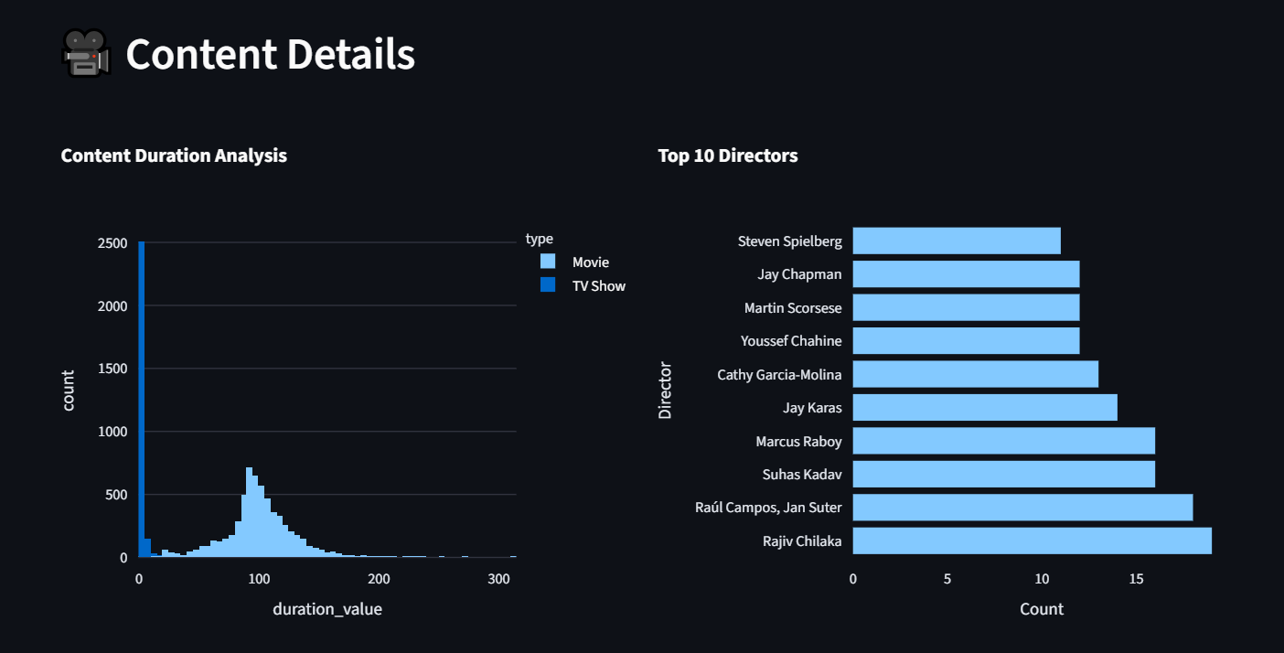

Dataset Preview
